Here’s a summary of the virtualization analysis pros and cons based on the infographic reviewed in the article:  ✅ Pros of the Virtual Water Infographic Visualization  - Clear Purpose  - It effectively communicates the importance of water footprint awareness.  - Structured to guide the viewer from definition to global impact.  - Thoughtful Color Use  - Blues for water-related data → intuitive and thematic.  - Greys to de-emphasize less important info.  - Black background sets a serious tone, implying urgency.  - Strong Visual Metaphors  - Icons like taps, droplets, crops, and maps help simplify complex data.  - Visual elements align well with the topic’s meaning and are easy to remember.  - Tailored for Broad Audiences  - Accessible to the public, students, and professionals.  - Balances visual appeal with informative content.  - Accurate and Honest  - Uses reliable, fact-based data without exaggeration.  - No misleading visuals; data is shown clearly and appropriately.  - Minimalism & Simplicity  - Avoids clutter; each element has a purpose.  - Prioritizes clarity without being overly basic.  ❌ Potential Cons or Limitations  While the article praises the visualization heavily, possible limitations include:  - Limited Interactivity (if digital)  - If viewed as a static image, it may not allow deep user exploration or filtering by country or region.  - Colorblind Accessibility  - Reliance on blue/grey shades might reduce effectiveness for users with color vision deficiencies.  - Quantitative Detail  - Visual metaphors (droplets, maps) are powerful but may oversimplify numeric comparisons if not accompanied by exact values.  - Language or Regional Bias  - Viewers unfamiliar with water use terminology (like "virtual water") may need additional explanation.  📌 Conclusion:  This infographic is a very strong example of good visualization practice — clear, aesthetically aligned, minimalistic, and purposeful — but like any static visual, it could benefit from interactive or dynamic features for deeper analysis.  Would you like help turning this kind of design into an interactive R or Python dashboard? | Based on the article on the Virtual Water Infographic by Chesca Kirkland, here’s a summary of the virtualization analysis — pros and cons:  ✅ Pros of the Visualization (Strengths)  - Clear Purpose & Storytelling  - Effectively raises awareness about water use and the concept of virtual water.  - Walks the viewer from basic facts to impactful conclusions, culminating in a global comparison.  - Smart Use of Color  - Blue for water = intuitive, thematic.  - Grey for less important elements reduces distraction.  - Dark background adds emotional weight (e.g., seriousness of the issue).  - Effective Pictorial Elements  - Uses taps, droplets, maps, and icons to match concepts.  - Visual metaphors help viewers remember and emotionally connect with the data.  - Audience-friendly Design  - Accessible to a general audience, students, and professionals.  - Avoids jargon and overwhelming stats — visually digestible.  - Data Integrity  - Honest, transparent data presentation without distortion or misleading visuals.  - No exaggeration or “data beautification” that compromises clarity.  - Simplicity & Clean Layout  - Minimal visual noise; clear focus.  - Uses emphasis (bolding, color contrast) to highlight key points.  ⚠️ Potential Cons or Considerations (Limitations)  - No Interactivity  - It’s a static infographic; users can’t explore details interactively (e.g., tooltips, filters, drill-downs).  - Data Depth Limited by Visual Space  - Prioritizing simplicity may leave out regional or per-product specifics that some advanced users might want.  - May Require Some Contextual Knowledge  - “Virtual water” as a concept may still be unfamiliar to some viewers without brief prior explanation.  - Cultural/Regional Bias  - The global map and usage examples may center on certain regions more visibly than others (depending on how the map is styled).  📌 Summary:  Aspect Evaluation  Clarity Excellent — intuitive, clean, focused  Emotional Impact Strong — via visuals and color choice  Honesty High — avoids manipulation or overload  Data Depth Moderate — balanced for a general audience  Engagement High visually, but limited interaction
во просек 10 галони дневно од вашиот воден отпечаток се губи поради протекување (10% од вашата внатрешна употреба) | on averaging 10 galons per day of your water foot print is lost to leaks (10% of your indor used) 3.78541x 10=37.78541 lit. lost  ne se znae koku e vo prosek dnevna potrosuvacka

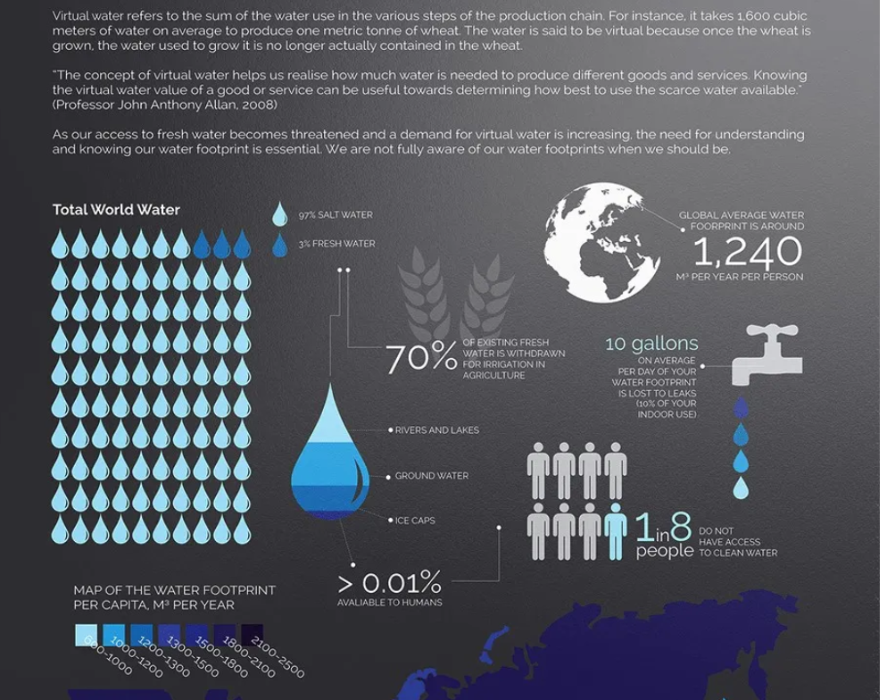
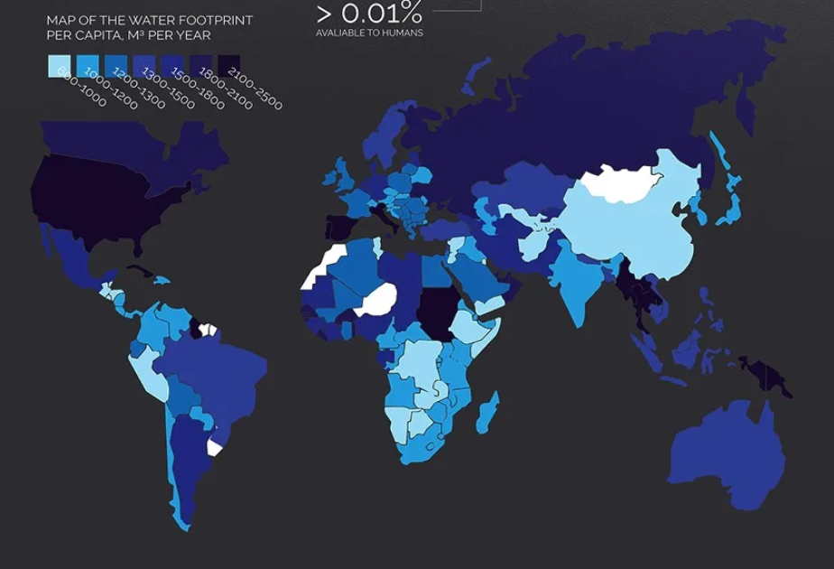

Recenzija vo clanok

Defining clear purpose  This particular visualization was made to raise awareness about water footprint and it rightly served its purpose by giving enough information without deviating into another direction. | It started by explaining what virtual water refers to, then enlightened us with how much of the world’s water is freshwater, how much of it is used in agriculture or wasted due to leeks, and how many people have access to this clean water. Finally closing it with an excellent representation of a world map showing the water footprint per capita, M3 per year.  Any person spending only 5 mins on this visualization will not only have an increased awareness of the water we use but will also have an impact to use it judiciously.
Color palette  Colors are an effective medium for communicating meaning. a crucial tool to convey the underlying data accurately | In this visualization, one can say that the colors were smartly chosen as shades of blue, as blue depicts water, and choosing a grey color for less important information and images. Not only the choice of color but also the use of a darker shade to emphasize the key information making the viewer more focused on what’s important.  background black gives us a perception that the topic we are talking about is having an adverse impact on the world.
Pictorial Representation  Creating highly customized visuals helps produce pieces that can be easily remembered and can make an impact: images that people can recall in their minds as the jump-in point to the topics, information, and knowledge. | Not only the map visualization but also showing leaks with the help of an image of a tap, portrayal of people when talking about how many of them have access to clean water, making use of water droplets to show the percentage of fresh water and then showing the distribution of various water bodies with a single water droplet, picturing the globe when speaking about the global average water footprint and lastly depicting the usage of fresh water for irrigation in agriculture with a faded crop like image.
Made for audience | It is important to match your visualization to the viewer’s information needs. Whether a normal magazine-reading person or a student studying the Virtual water infographic topic or an organization analyzing the water footprint in the world, this data visualization will be insightful and interesting to all of them. It makes it easier to reach a larger audience who can understand the presented information quickly and consider the outcomes from the data.
Avoiding Misleading Information  It is one’s social responsibility to be truthful to the audience when making a data visualization on a topic like water consumption. As it can easily impact them in a negative way if not transferred correctly. | The visualization above has an apt amount of information, neither too much nor too less. It did not try to hide the important points or sugar-coat them to make them more positive, it stated facts based on thorough and honest research. The use of colors made sense and wouldn’t cause accidental misinterpretation among the audience. It is indeed remarkable that only the information which was relevant and related to each other was shown in it.
Leaving the Noise Off  Data alone is just noise. Presenting that data in an easy-to-read format that is clutter and confusion-free, is a skill that the owner of this visualization possesses. | One can say the visualization above is clean, and minimalistic and has emphasized all the key points. It has used colors like grey to decrease the importance of secondary elements and increased focus on elements by adding color and bolding. The shades of blue used to show the water footprint according to the region, make it easy for the viewer to compare. We can say that everything has a purpose, nothing is superfluous.
Comclussion: Chesca Kirkland has not only enlightened us with enough information but in a way encouraged us to be empathetic for the people who do not have access to clean water and change the ways in our day-to-day life which may be resulting in the wastage of water. It indeed is a great visualization not only because of its excellent representation but also because of the important message it is delivering.

GTP
Pros of the Visualisation
Clear Purpose & Storytelling | • Effectively raises awareness about water use and the concept of virtual water.  • Walks the viewer from basic facts to impactful conclusions, culminating in a global comparison.
Smart Use of Color | • Blue for water = intuitive, thematic.  • Grey for less important elements reduces distraction.  • Dark background adds emotional weight (e.g., seriousness of the issue).
Effective Pictorial Elements | - Uses taps, droplets, maps, and icons to match concepts.  - Visual metaphors help viewers remember and emotionally connect with the data.
Audience-friendly Design | - Accessible to a general audience, students, and professionals.  - Avoids jargon and overwhelming stats — visually digestible.
Data Integrity | - Honest, transparent data presentation without distortion or misleading visuals.  - No exaggeration or “data beautification” that compromises clarity.
Simplicity & Clean Layout | - Minimal visual noise; clear focus.  - Uses emphasis (bolding, color contrast) to highlight key points.

Potential Cons or Considerations (Limitations)
No Interactivity | - It’s a static infographic; users can’t explore details interactively (e.g., tooltips, filters, drill-downs).
May Require Some Contextual Knowledge | - “Virtual water” as a concept may still be unfamiliar to some viewers without brief prior explanation.
Cultural/Regional Bias | - The global map and usage examples may center on certain regions more visibly than others (depending on how the map is styled).
Summary GTP  Aspect  Clarity  Emotional Impact  Honesty  Data Depth  Engagement | Evaluation  Excellent — intuitive, clean, focused  Strong — via visuals and color choice  High — avoids manipulation or overload  Moderate — balanced for a general audience  High visually, but limited interaction

Virtual Water Infographic – Visual Critique Summary
Aspect | Strengths (✔️) | Weaknesses / Suggestions (⚠️)
Design/Layout | ✔️ Clean and appealing layout  ✔️ Use of consistent icons for food items | ⚠️ Icons could be scaled more proportionally to volume  ⚠️ Better use of negative space
Color Usage | ✔️ Distinct colors help differentiate items  ✔️ Soft palette easy on eyes | ⚠️ No color key—meanings are assumed  ⚠️ Color doesn't convey value (i.e., no gradient)
Typography | ✔️ Readable fonts for main values | ⚠️ Smaller text (sources, labels) may be hard to read on small screens
Data Presentation | ✔️ Provides clear water volume per item (e.g., steak, chocolate) | ⚠️ No units conversion (e.g., gallons vs m³)  ⚠️ Lacks statistical context or variability
Clarity of Message | ✔️ Simple takeaway: some foods use much more water | ⚠️ No clear comparison to daily water usage  ⚠️ Doesn’t explain why water use differs
Source Transparency | ✔️ Source listed at the bottom | ⚠️ Source not prominently highlighted  ⚠️ No mention of data uncertainty
Interactivity | N/A (static infographic) | ⚠️ Could benefit from interactive elements in digital formats (hover info, filtering)

Moi zabeleski
Cons
Second subpicture showing source of fresh water is not clear enough: | It is written that 70% of fresh water is withdrawn for irrigation.  What about the rest 30%? It is contained in rivers and lakes, ground water ice caps and less than 0.01% available for humans? But water for humans come from rivers lakes ground water as also water for irrigation. So there is unclear of what we want to present
Third and fourth subpicture has mismatch in measures | Global average water footprint is around 1,240 M3 per person/year, (is it indoor usage?), but average (indoor) lost per day is shown in gallons (10 gallons). Also saying that this is 10 % of indoor use.  10% of average person/year of 1240m3 is 124m3. Daily it is 124/365=0.339m3 which 89.56 US gallons or 74.52 UK (imperial ) gallons. Far more than reported
Data surely vary by year | There is no information of year of the data
Own experience | My grand parents (2 persons) use indoor water in average 15m3 per month that is 15x12 =180m3 per year. They think about themselves as rather average situated persons, and there is no restriction of water supply in place of leaving. This information is far lower than the lower 600-1000 m3 reported.

